Registering for the Learn-IT Conference via TDM
  - Prepared by Hal Hinderliter hhinderliter1@niu.edu

Introduction
This year’s Learn-IT Conference is a virtual event, hosted on the Blackboard learning management system. In order to provide access to attendees from outside of NIU, we are using Blackboard’s Training and Development Manager (TDM) system. Unfortunately, this complicates the process of enrolling in Learn-IT courses. The following job aid shows how to access the Learn-IT conference, beginning with the public webpage for the conference followed by TDM registration then into the Blackboard course.

Assumptions
- These instructions assume that you have a reliable connection to the Internet and are already familiar with how to use a web browser. It is also assumed that a suitable web browser is already installed and operational on your computer.

Instructions
- Verify that your web browser is configured to accept third-party cookies. View directions on how to enable cookies for all major web browsers.
- Use a web browser to access the conference’s public webpage
- Click the red "Register for Learn-IT" button; this will open the TDM webpage.
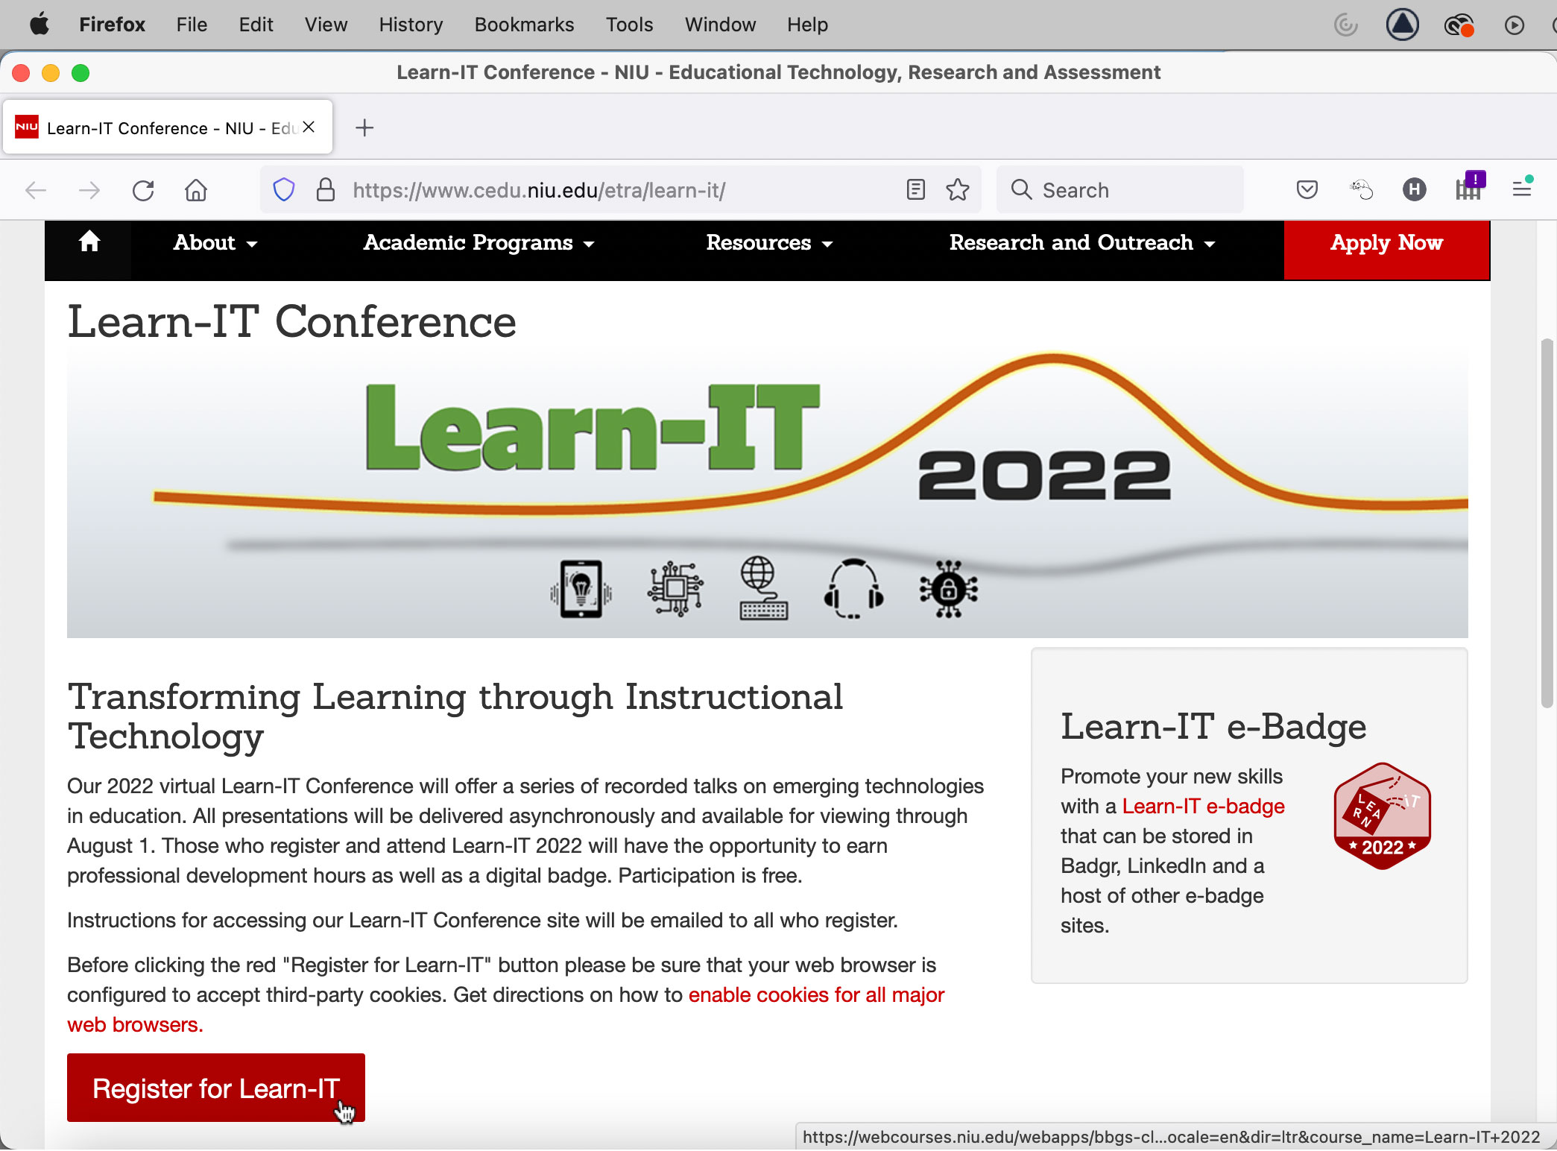

- The TDM webpage should display a tile for the Learn-IT conference (if it does not, use the “Refine your search” box to search for Learn-IT). Click on the purple “Enroll Now” button on the Learn-IT tile.
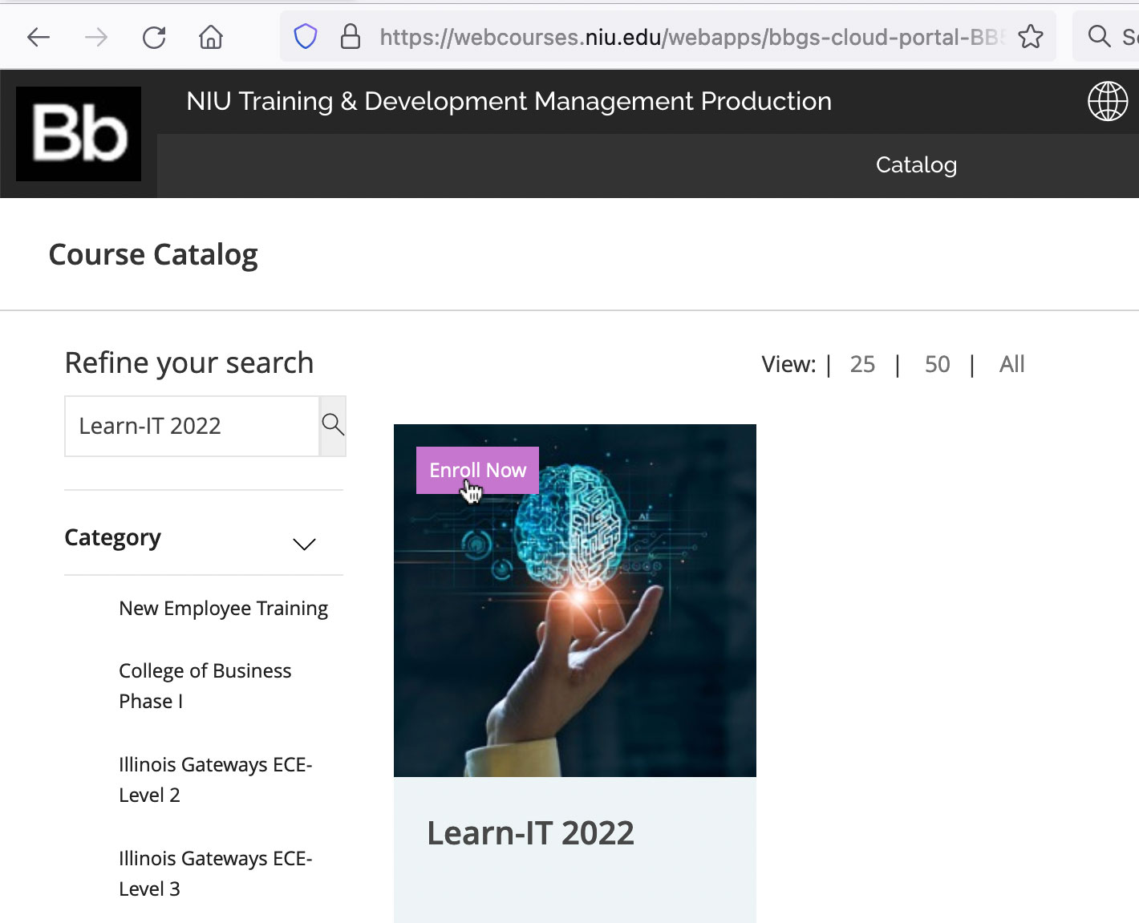
- This will cause a new window to open from the right side of your screen, displaying the TDM catalog page for Learn-IT. Within the catalog page is a large gray box, which contains another purple “Enroll Now” button. If you do not see a purple Enroll Now button on this catalog page, please try accessing the site using a different web browser. (The Safari and Chrome browsers on the Mac platform occasionally fail to display the button.) Click the purple “Enroll Now” button.
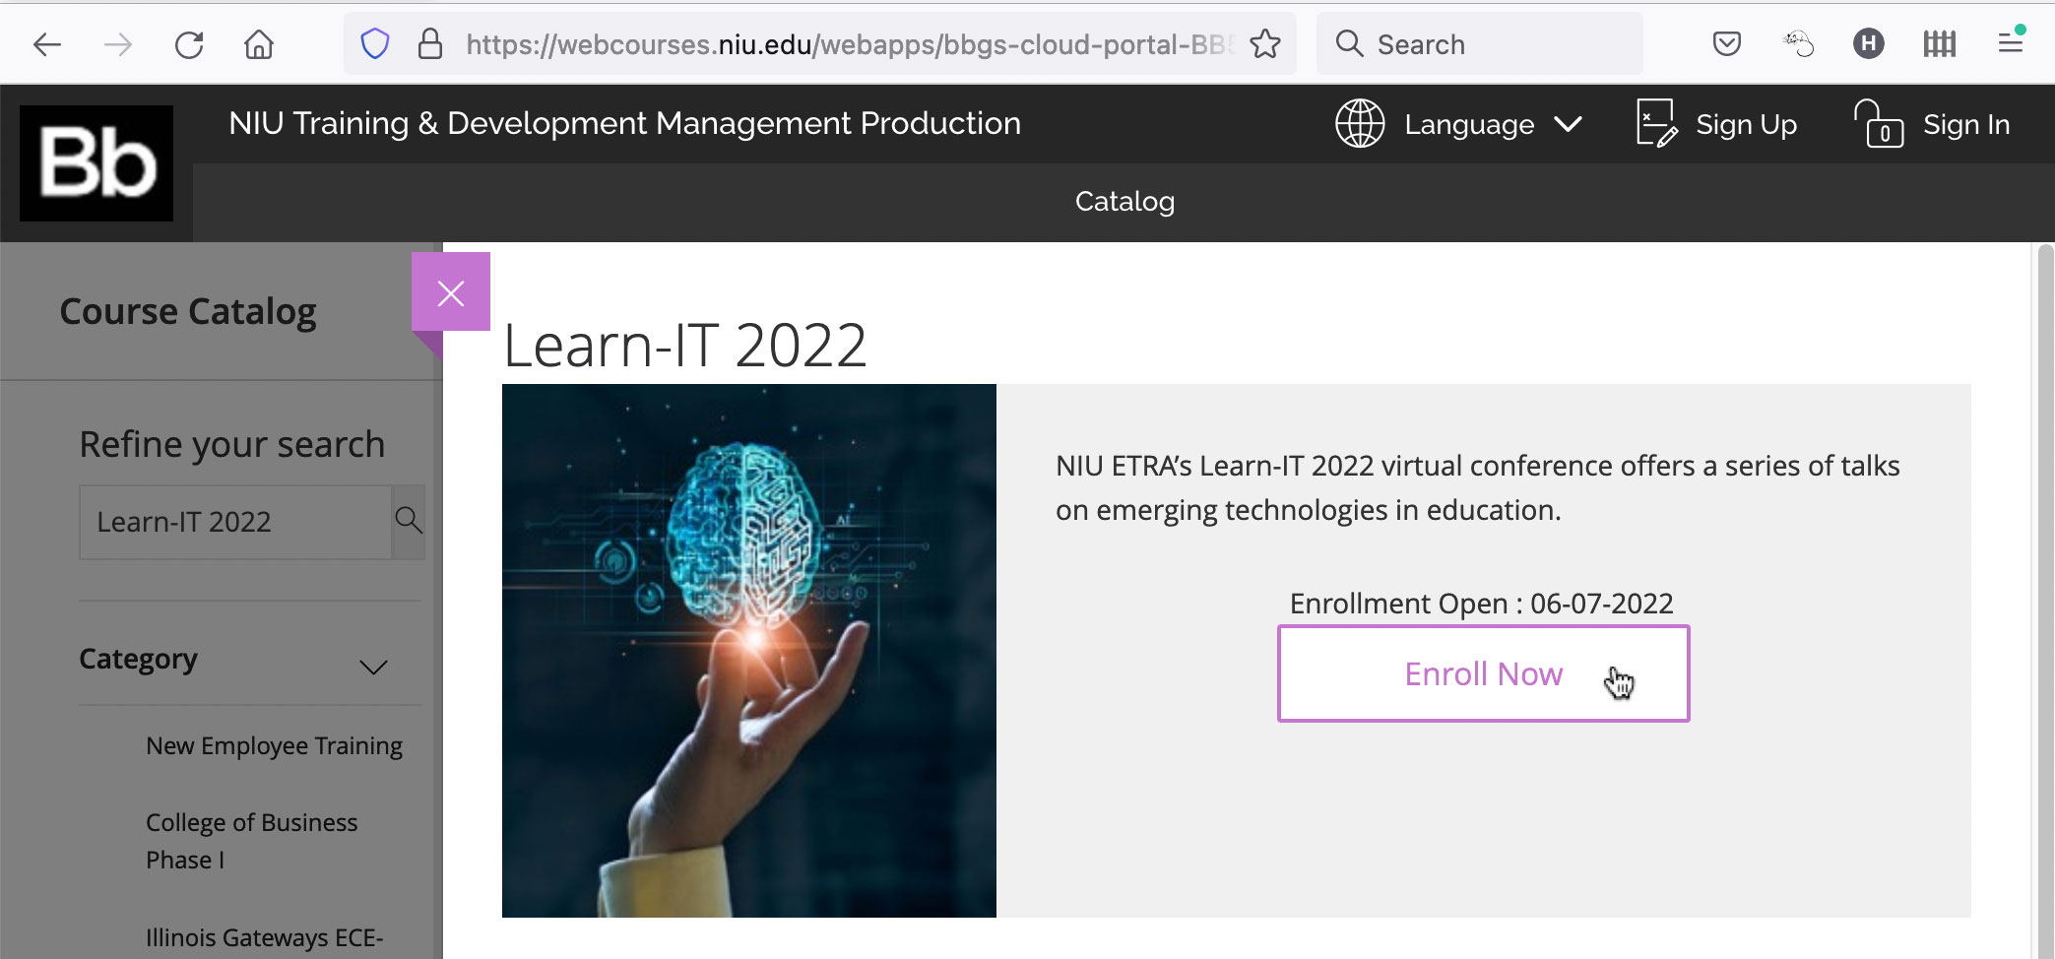

- A pop-up window should open, containing the message, “You need to register or login to be able to enroll.” In you already have NIU log-in credentials, click the “Sign In” button. If you do not have NIU log-in credentials, click the “Sign Up” button.
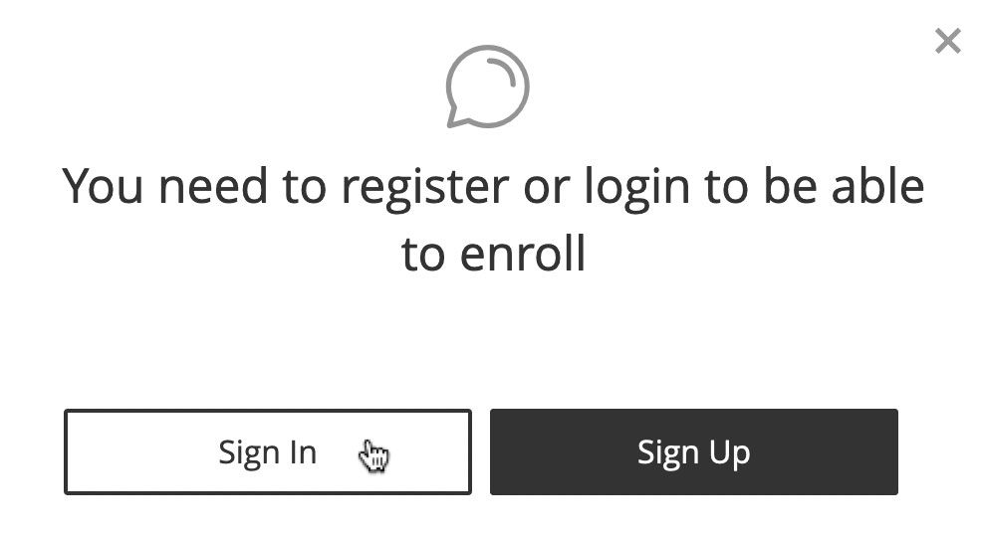
- Please complete the sign-up process if you do not have NIU log-in credentials. If you already have NIU log-in credentials, proceed to the next step.
- Clicking the “Sign In” button opens NIU Training and Development Sign-In Instructions webpage. By default, this webpage is set to accommodate non-NIU participants, who will need to log in to their Blackboard TDM account using the Username and Password obtained in the previous step. If you already have NIU log-in credentials, you must click on the radio button in front of the words, “Log in with your NIU AccountID” then click the resulting red “log in” button.
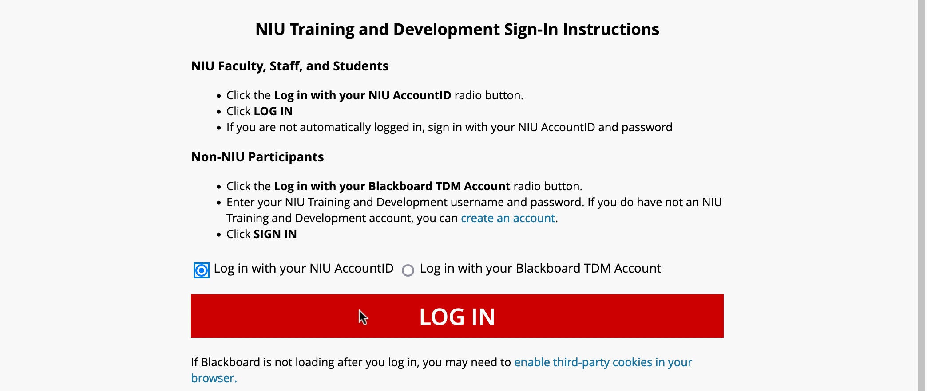
- The first time you click the red “log in” button, you may be required to complete a two-factor authentication challenge. (Enter a text code that is sent to your mobile phone or email.)
- Once you’ve successfully logged into the TDM Course Catalog site, use the page numbers at the bottom of the screen to get to the last page of the catalog. Locate the Learn-IT tile on that page, then click it.
- This time, the large gray box on the catalog page should contain a purple button that says, “Go to My Dashboard.” Click it to access your TDM Dashboard.
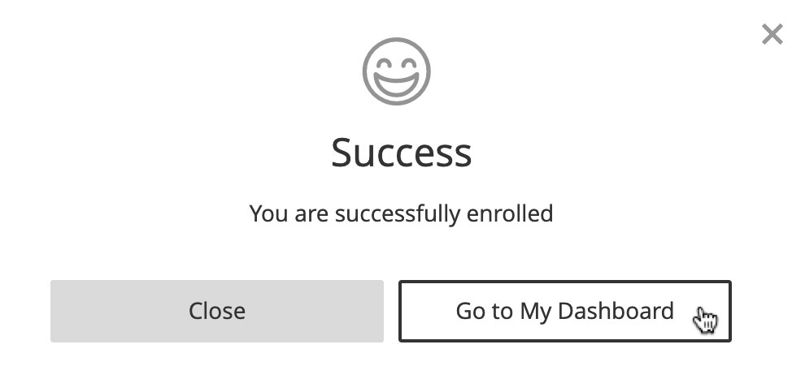
- From the Dashboard page, look to the right side of the window to find a purple button that says, “Continue Course.” Click it to access the Blackboard course.
